How to use Virtual Masking Lab source control on SourceForge.net
- Download and Install AnkhSVN from http://ankhsvn.open.collab.net/downloads
  - Registration is NOT required if you click the Skip registration and download the software button on the download page.

- Ensure AnkhSVN is selected as Visual Studio source control by:
  - Select Tools -> Options
  - On the right, under Source Control select Plug-in Selection
  - For Current source control plug-in, ensure AnkhSVN – Subversion for Visual Studio is selected
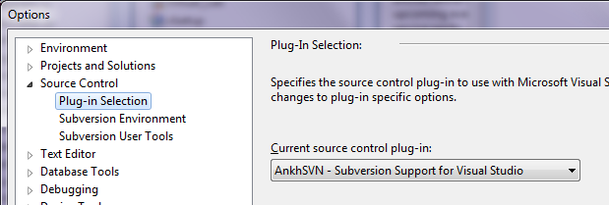

- Add Virtual Masking Lab to the Repository Explorer
  - In Visual Studio select View -> Repository Explorer
  - Click the Add a new URL to the Repository Explorer icon
  - Specify the following URL and click OK: https://virtualmaskingl.svn.sourceforge.net/svnroot/virtualmaskingl/Virtual_Lab/
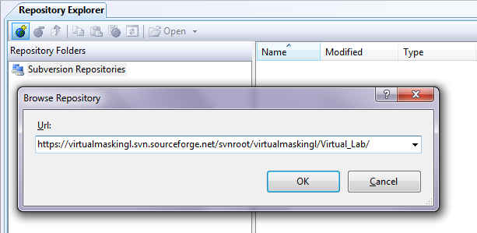
- Open the Virtual Masking Lab solution in Visual Studio:
  - In the Repository Explorer left pane, select the Virtual_Lab folder under svnroot/virtualmaskingl/
  - Select the file Virtual_Lab.sln from the files on the right pane
  - Click the Open Icon
  - Ensure the Type is set to Latest Version and specify a local path from which to work with the Virtual Masking Lab solution (The default should suffice) and click OK
  - Allow a moment for the project to download.
  - You are now ready to begin modifying the code.
  - To load the project in the future just reload the local copy and update it using the SVN

- Once you have finished modifying a source file, it must be Committed to update the source code on SourceForge.net so that other developers may use the new revision
  - If the Pending Changes window is not shown in Visual Studio, navigate to View -> Pending Changes
  - Click the Update button to ensure your files have the latest changes made by another developer. If a conflict should arise, see step 6 to resolve the conflict
  - From the list of files that you have made changes too, ensure the files you wish to commit are checked, and uncheck the files that you DO NOT wish to commit.
  - In the text box above the list of files, type a short message that specifies the changes you have contributed to the project.
  - Click the Commit button
  - Your modifications are now available to other developers

- If two developers modify the same lines of code in a file and the other developer commits before you do, a conflict arises and it must be resolved before your changes can be committed.
  - Right Click the conflicting file in the Pending Changes window and navigate to Resolve
  - The list of options should be self explanatory.
    - The Resolve Conflict option will allow you to personally make the appropriate changes necessary to adapt your changes with the other developers committed changes.
    - The Using Original File option will revert any changes back to the previous revision prior to the changes you or the other developer made
    - The Using My (Their) File option will resolve the conflict with only your (their) changes.
  - Once the conflict has been resolved you may commit your changes.

